**How Companies Think About Data**

Understanding the Fundamentals of Using Data.

October 31, 2023

**The following three charts offer a quick** overview of how companies think about data. The first, “Creating New Value with Data,” shows how simple analytics, applied by individual products to their own data, reveal basic insights. And how more-sophisticated analytics, applied to product data that has been pooled into a “lake” with data from external and enterprise sources, can unearth deeper insights.

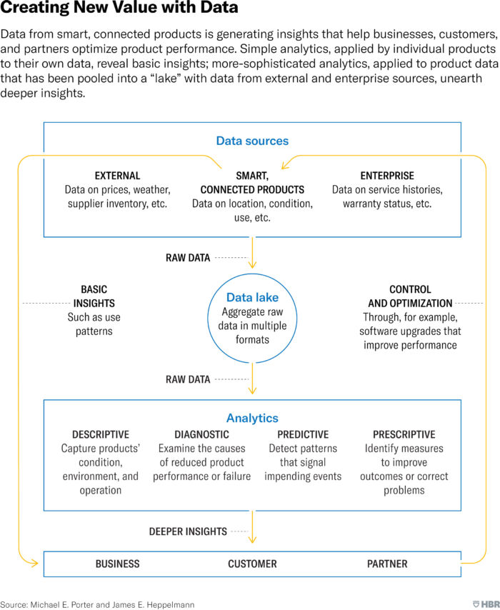

[See more HBR charts in Data & Visuals ](https://archive.is/o/oVoaP/https:/www.hbr.org/data-visuals)

Data, like all information, comes with risks. And so the second graphic in this collection offers an overview of data strategy (see “The Elements of Data Strategy”). Leandro DalleMule and Thomas H. Davenport published the model in 2017 as a framework to help managers clarify the primary purpose of their data, whether it’s to be “defensive” or “offensive.” Data *defense* is about minimizing downside risk: ensuring compliance with regulations, using analytics to detect and limit fraud, and building systems to prevent theft. Data *offense* focuses on supporting business objectives such as increasing revenue, profitability, and customer satisfaction.

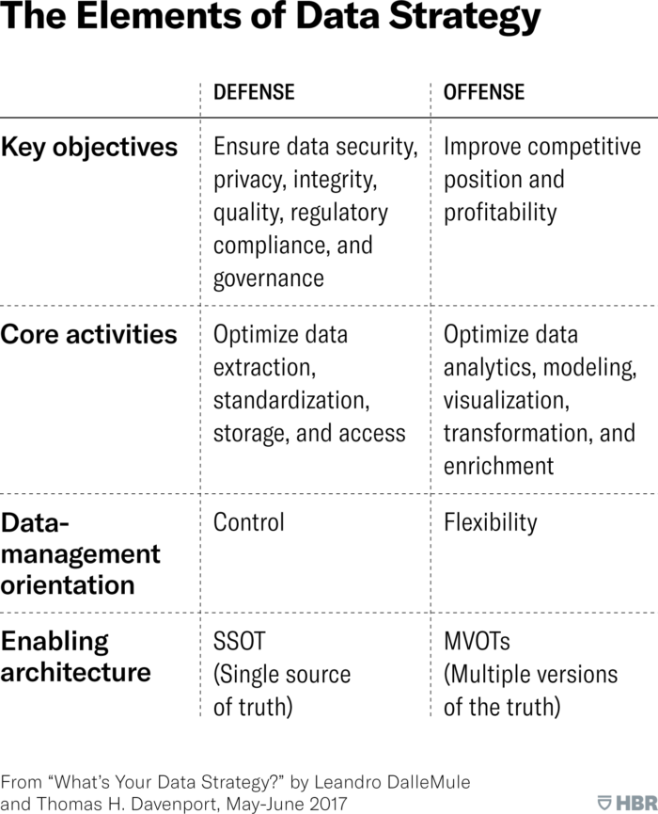

Finally, “5 Essential Elements of Succeeding with Data” shows us what it takes to use data well — and what happens when an essential piece is missing.

